Minburn Moments

FREE!!

JULY ‘22

NOW AVAILABLE!

Water payments available to pay online!

Stay informed, visit https://www.minburn.org

**Community**

**Calendar**

**7/7-**Library Board Mtg. 6:30pm

**7/14-**Adult Book Club 11am

**6/11- Jake Kemble Concert- 7pm**

**Meal 5:30-7:30**

**6/13-** City Council Mtg. 7pm

**6/14- Summer Reading Kick Off**

**Magician Mikayla Oz- 6pm @Library**

**6/16-** Evening Skating 7pm-Meek Park

**6/17-** Open Skating 10-Noon

Kids Book Club- 2:30pm

**6/20-** Movie Monday- Encanto

**6/22-** Brenton Arboretum 10am

**6/23-** Art of Tarot Class- 6pm

Evening Skating 7pm

**6/24-** Open Skating 10am

**6/25- OUTDOOR MOVIE- SING 2- Meek Park 8pm**

**6/27-**Movie Monday Cheaper by the Dozen(22)

Minburn Community Betterment Group presents…

Summer Concert Series

June 11th- Jake Kemble

Meal provided by Minburn Library- hotdog, chips, cookie, and drink-Free Will Donation 5:30-7:30

July 3rd- Robbie Michael Band

Meal provided by Friends of the Minburn Library- Walking Tacos

Free Will Donation 5:30-7:30

August 13th-Roger Burger

Meal provided by Minburn Volunteer Fire Department

The Concerts begin at 7pm the skating rink will be open for skating at each concert. All Free of Charge.

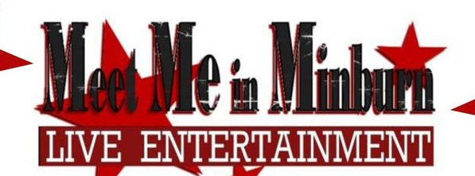

Minburn 4th of July theme…

MINBURN STRONG

Thank you to The American Legion Auxiliary, Megan Cline and the Minburn Community Betterment Group for making this event possible.

More details to come as we get closer.

The Minburn Library is looking for anyone who would like to ride/walk on our float with us in the July 4th Parade.

Minburn Strong, Strong Support, Strong Library!

We wouldn’t be the strong library we are today without your help. We are in a great, new location and we would like to celebrate! We will be handing out bookmarks, and throwing candy. All ages are welcome! Contact the library if you are interested.

515-726-3900, library@minburnlibrary.com

.

Join us June 9th to discuss

“Under the Same Sky” by Cynthia DeFelice. 11:00am

Next Book: “Midnight Library” by Matt Haig July 14th 11:00am

Check out our website [www.minburnlibrary.com](http://www.minburnlibrary.com) or our Facebook page [www.facebook.com/minburnlibrary](http://www.facebook.com/minburnlibrary) for more details.

SUMMER READING KICK OFF!

JUNE 14TH

6:00PM

At the Minburn Public Library

Popcorn will be provided. Sign up for the summer reading program can be done at the event or anytime after June 14th at the library.

For questions contact the Library 515-726-3900

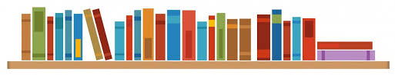

Library Hours: Mon. 10-6, Tues. 3-7, Wed.- Fri. 10-4, Sat. 10-12, CLOSED SUNDAY