Sept. 19, 2016

**FREE**

**Minburn Moments**

Community

Calendar

September

20th- Book Club

11:00am

Story Time 1pm

21st- Wednesday Club

5:45-7:15pm

22nd- LEGO Club

6-7pm

26th- ADM- NO SCHOOL

27th- Story Time 1pm

28th-Wednesday Club

5:45-7:15

29th- LEGO Club

6-7pm

**October**

4th-Story Time 1pm

5th- Craft Club 7pm

Wednesday Club 5:45-7:15 Methodist Church

6th- LEGO Club

6-7pm

11th- Story Time 1pm

12th- Early Out

Halloween Craft

13th- LEGO Club

6-7pm

18th- Book Club 11am

Story Time 1pm

20th- LEGO Club

6-7pm

21st- American Legion Fish Fry 5:30-7pm

22nd- Adult Coloring Party 7pm

24th-ADM NO SCHOOL

25th- Story Time 1pm

27th- LEGO Club

6-7pm

31st-Halloween

Trick or Treat

Formerly the Pinhook Page

**Beef Barley Soup**

Yield: Serves 8

Ingredients2 pounds stew meat (nicely marbled beef chunks)

salt and pepper

2 tablespoons oil

10 cups water

3 mounded tablespoons good quality beef base*

3 stalks celery (about 2 cups), chopped

2 onions, chopped

5 cloves garlic, minced

1 large potato, peeled and shredded, about 2 cups

3-4 large carrots, peeled and shredded, about 2 cups

1 cup barley, rinsed

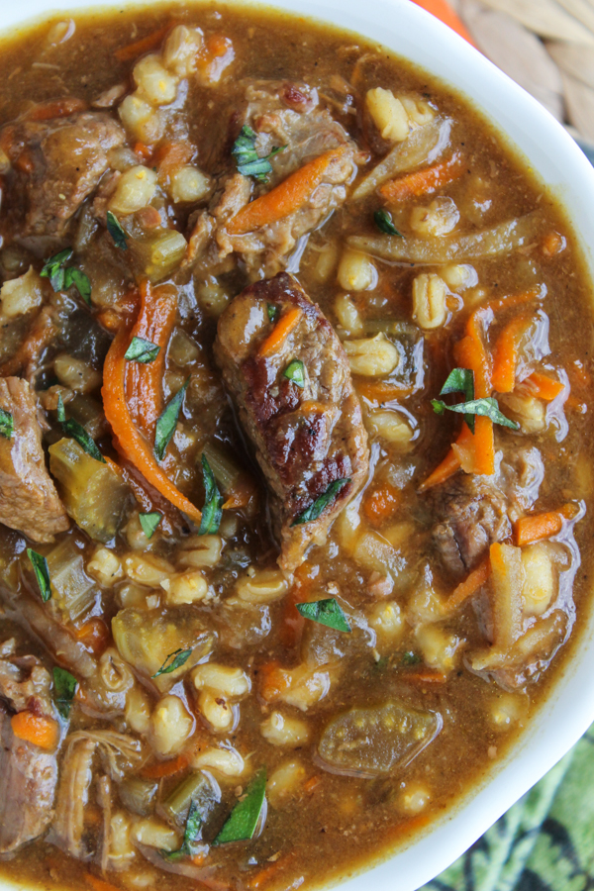

**Instructions**

Generously salt and pepper the beef. In a large stockpot, heat the oil over medium-high heat.

When it is very hot, add about 1/3 of the meat. Brown for about 1-2 minutes, then turn to brown the other side. Remove to a plate when it is browned on all sides.

Repeat with remaining meat in 2 more batches. (If you add it all at once it will steam the meat instead of browning it--not what you want.)

When all the meat is browned, add all the meat back to the pot with 10 cups of water. Add 3 healthy tablespoons beef stock concentrate.

Add the chopped celery, onions, and garlic. Bring to a boil, then turn the heat to medium-low. Simmer for about 2 hours with the lid on.

When the meat is tender and you can break it apart easily with a wooden spoon, add the shredded potato and carrots. Bring to a boil, then continue to simmer on low for another 30-45 minutes, or until the carrots are tender.

Add 1 cup of barley. Bring to a boil, then reduce to low. Cook for another half hour, or until barley is tender and the soup tastes...like home.

Slow cooker instructions:

In a large pan, brown the meat according to the instructions. Remove the browned meat to a large crockpot.

Add 2 cups of the water to the pan and bring to a boil. Stir up all the browned bits. Add this and the remaining 8 cups of water to the crock pot.

Add the beef base, celery, onions, and garlic to the slow cooker and stir.

Cook on low for about 6 hours. Add the potatoes and carrots and cook for another hour.

Add the barley and simmer for another hour or so, until it is tender.

American Legion Fish Fry

October 21st

5:30pm -7:00pm

Minburn Legion Hall

319 Baker St

Free Will Donation

American Legion Veterans Dinner

November 10th

5:00pm

Minburn American Legion Hall

Wednesday Club

5:45-7:15pm

Minburn Methodist Church

Meal provided

The City is looking for volunteers to plan and put together next year's 4th of July Celebration if you are interested in helping please contact city hall

# Have something to announce or advertise? How about something to sell? Put it on the Minburn Moments page! Contact Nicole at The Minburn Library call

# 515-677-2712 , email minburnlib@minburncomm.net, or stop by I would be glad to add it in the next issue. Currently bi-monthly production.

Saturday Morning

blood pressure checks are being postponed until further notice. Please stay tuned to see when they are being started again!



Area Churches

**United Methodist**

**Church**

Wednesday Club

Wednesday's

5:30-7:15pm

Church Service 11am

**Washington Chapel Church of Christ**

Sunday School 9:30am

Church 10:30am

Gym Time

FRIDAY'S

10am-NOON

playtime and story time together!

Minburn Elementary Gym

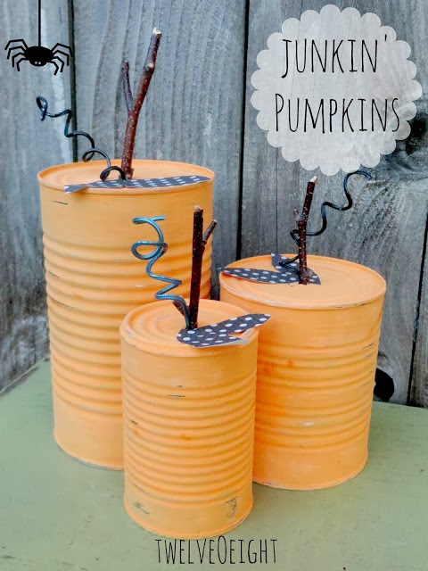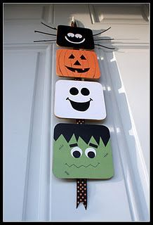

*Craft Club*

*October 5th*

*7pm*

*Minburn Legion Hall*

*make either of these crafts or bring your own*

*supplies will be provided*

Adult Coloring Party

October 22nd

7:00pm

@ Minburn Legion Hall

Bring own Drinks, snacks provided

Early Out

Halloween Craft!

Wednesday October 12th

Join me at the Minburn Legion Hall

for a fun craft.

2:00pm

snacks will be served all ages welcome

Minburn Legion Hall

**Library** hours

Monday -12-5:30pm

Tuesday - 12-5:30pm

Wednesday - Closed

Thursday - 12-5:30pm

Friday - 12-6pm

Saturday- 9am-Noon

LEGO Club

LEGO time will be THURSDAYS this fall!

we will meet weekly

from 6-7pm

at the Legion Hall unless otherwise posted

This publication brought to you by the

Minburn Public Library

No SChool September 26th

No school October 24th



**Book Club**

**October 18th**

**11:00am @ the Library**

**Americanah**

By: Chimamanda

Ngozi Adichie

Reader of the Month

Children stop in and check out a book and for every book you check out your name is entered into a drawing. The last day of the month the reader of the month is drawn.

The winner receives a crown, goody bag and your name will be displayed all month.

Story Time

*NEW TIME*

During Gym time

Friday Mornings

Minburn Elementary Gym

10-NOON-Story time last 30 minutes



Reading

Rules

Library News!