Sept 13th, 2017

**FREE**

*Minburn Moments*

Formerly the Pinhook Page

Annual Fall Minburn

American Legion

Fish Fry

October 20th

Minburn American

Legion Hall

319 Baker St.

5:30-7:30pm

Wednesday Club

Wednesday's from 5:45-7:15

Minburn Methodist Church

meal provided

Sunday School 10:00am

Sunday Mornings

followed by church at 11:00am

Community

Calendar

September

13th- Wacky Wednesday-

ADM 1:00 dismiss

Library Event- 2-4pm

Meek Park Skating Rink

Wednesday Club-

5:45-7:15pm

14th- Lego Club 6-7pm

Legion Hall

15th- Pig Roast

Washington School

5:30-7:30pm

20th- Wednesday Club

5:45-7:15pm

25th- Wednesday Club

5:45-7:15pm

**NO SCHOOL ADM**

27th- Wednesday Club

5:45-7:15pm

October

4th- Craft Club 7-9pm

Minburn Legion Hall

Wednesday Club

5:45-7:15pm

5th- Library board meeting 6:30pm

11th- Wacky Wednesday- ADM

Movie- Boss Baby

2-4pm Minburn Legion Hall

Wednesday Club

5:45-7:15pm

16th- **NO SCHOOL ADM**

17th- Wacky Wednesday- Critter Cindy 2-3pm- Legion Hall

***NEW***

First Annual

Trunk or Treat

October 31st

6:00-8:00pm

We are adding to the traditional trick or treating experience with TRUNK OR TREAT! It will be held on

Baker St. in front of library. Baker street will be closed from the vets office to the Legion hall during this time. Anyone is welcome to participate. Park your car and hand out goodies to kiddos. Trunk decorations are encouraged, but not required. There will be a few games outside depending on weather.

DONATIONS NEEDED!

The Minburn Library is collecting gently used items (no clothing) for our **“1st Annual Christmas Shop for Mom and Pop”** on Saturday, December 2nd (time tbd).

Kids are able to come ‘shop’ for a gift for mom and a gift for dad and have it wrapped….all for free! So parents have something special under the tree.

If you have items you would like to donate, please drop your items at the Library or contact Librarian, Nicole Connick at #677-2712 or Friend, Laura Bengtson at 677-2084. We will also pick up your items, if needed.

We would also love donations of gift wrap, tape, bows, and gift tags!

Donations being accepted now thru November 18th.

Left over items will be donated

PIG ROAST

Friday, September 15th

5:30-7:30pm

Washington School

Corner of P58 and F31

Saturday Morning

blood pressure checks are being postponed until further notice. Please stay tuned to see when they are being started again!

Area Churches

**United Methodist**

**Church**

Church Service 11am

**Washington Chapel Church of Christ**

Sunday School 9:30am

Church 10:30am



# Have something to announce or advertise? How about something to sell? Put it on the Minburn Moments page!

# Contact Nicole at The Minburn Library call

# 515-677-2712 , email library@minburnlibrary.com or stop by I would be glad to add it in the next issue. Currently bi-monthly production.

City Hall Hours

Mon,Tue,Thur,Fri-

8am- Noon, 1-5pm

Wednesdays- Closed

Sat and Sun - Closed

515-677-2245

LEGO Club

September 14th

October 12th

6:00-7:00

All ages welcome! Lego's and Duplo blocks will be provided.

No Charge

Library hours

Monday-12-5:30pm

Tuesday- 12-5:30pm

Wednesday- Closed

Thursday- 12-5:30pm

Friday- 12-6pm

Saturday-

9am-Noon

515-677-2712

*Craft Club*

*Halloween Wreath*

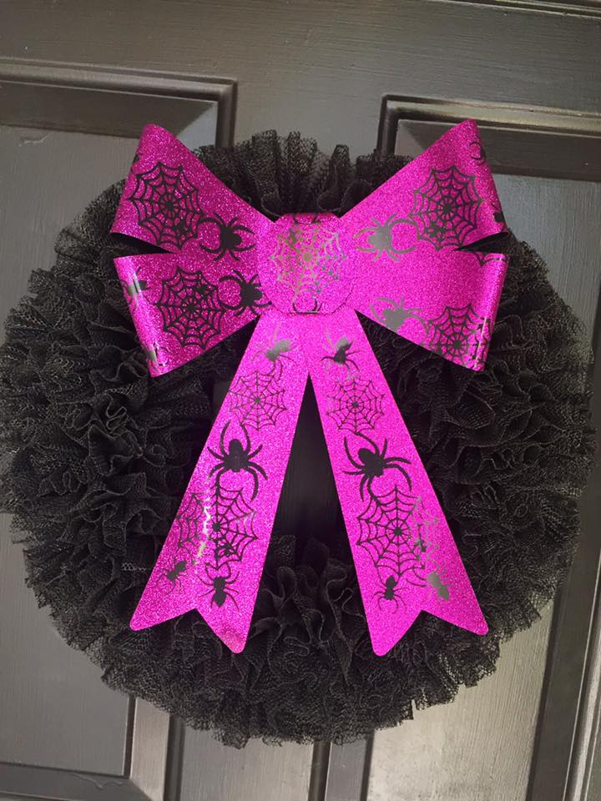

*October 4th*

*7:00pm*

*Minburn Legion Hall*

*Please bring a glue gun if you have it availvable.*

*Snack will be provided*

*Bring your own Drinks*

*$5 donation minimum due to the cost of this craft.*

*to RSVP either call the Library at 677-2712, email library@minburnlibrary.com or select 'going' on the Minburn Library Facebook page*

ADM NO SCHOOL DATES

September 25th, 2017

October 16th, 2017

November 22-24th, 2017

Sizzling Storytime!

Join us Monday afternoons at 3:00pm for some pint sized fun!

we will sings songs, and read books

geared toward ages 0-4

all ages are welcome

Friday Funday's

Yoga at 9:30am

Open Skating time

10:00am-Noon!

Meek Park Skating Rink

We do beginner kids Yoga, I have printouts for everyone!

There is no charge, skates and roller blades are provided

come join the fun!

**We will remain at Meek Park until the weather changes. At that time we will move to the Minburn Elementary Gym**

Wacky Wednesday!

October 11th

2-4pm-

Minburn Legion Hall

Movie- Boss Baby

snacks provided

Everyone Welcome

under 5yrs old please have an adult present.

October 17th

2-3:30pm

Halloween Balloon Twisting workshop

...presented by Pink Stew Entertainment.

Ages 5+

Minburn Legion Hall

Stay Tuned to this newsletter and our website...

**www.minburnlibrary.weebly.com**

so you don't miss out on the upcoming events here at

Minburn Public Library!

**New**Birthday Club**

Have a birthday

coming up?

Stop in the Library, have your picture taken with Beatrice our New Birthday Bear, and pick up your birthday

goody bag.

**Book Club**

**Discussion**

Sept. 18th 6:30pm

Sept. 19th 11:00am

**The Witches Daughter**

**By: Paula Brackston**

Everyone is welcome!

books are available at the library to be checked out

**October-I'll Push You**

**By: Patrick Gray/Justin Skeesuck**



Reading

Rules

This publication is brought to you by Minburn Public Library

Library News