**FREE**

*Minburn Moments*

Formerly the Pinhook Page

Community

Calendar

APRIL

**25-** Wacky Wednesday 2-4pm

MAY

**2-** Craft Club 7pm

@ Legion Hall

**3-** Library Board Mtg

6:30pm

**4-** Open Gym

10am-Noon

Minburn Elem. Gym

**7-** Story time 3pm

@ Library

**9-** Wacky Wednesday – Mother’s Day Craft

2-4pm @ Legion Hall

Ladies Night at MUMC- 6:30pm

**10-** LEGO Club-

6-7pm @ Library

**11-** Open Gym

10am-Noon

Minburn Elem. Gym

**12-** Secret Keepers

Tween Reading Group 10am @ Library

**14-** Story time 3pm

@ Library

**15-** Adult Book Club

11am @ Library

**18-** Open Gym

10am-Noon

Minburn Elem. Gym

**21-** Story time 3pm

@ Library

**25-** Open Gym

10am-Noon

Minburn Elem. Gym

**28-** Story time 3pm

@ Library

**31-** Last Day of School Party 2-4pm

Skating Rink

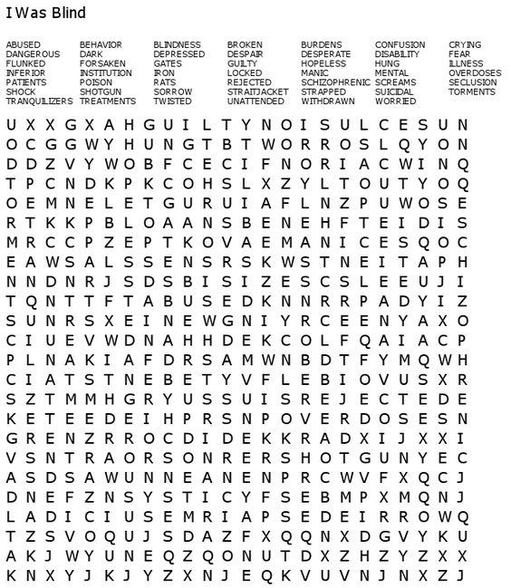

The Library is looking for volunteers to help plant the barrels downtown. If you are interested in helping plant or watering the barrels please contact the library 677-2712

The Adel Good Samaritan

Food Pantry of Adel will be delivering food boxes to Meek Park Fridays this summer. If you have children in the ADM school district you are eligible for these boxes by filling out the form that comes home with your student from school. If you don’t have an ADM student contact the Food Pantry directly at

(515) 423-0753 Each box contains enough food for 2 meals a day. Everyone is accepted.

Minburn UMC’s

Ladies Night

May 9th

At 6:30pm

Minburn Methodist Church

A Night of Fun, Faith, and Fellowship

Must be 18 or older

Meet Me in Minburn

Summer Concert Series

June 9th

Off The Cuff 7:00

4th of July Committee provides meal

More details to come

Saturday Morning blood pressure checks are being postponed until further notice. Please stay tuned to see when they are being started again!

Area Churches

**United Methodist**

**Church**

Sunday School 10am

Church Service 11am

**Washington Chapel Church of Christ**

Sunday School 9:30am

Church 10:30am

# Have something to announce or advertise? How about something to sell? Put it on the Minburn Moments page!

# Contact Nicole at The Minburn Library call

# 515-677-2712 , email library@minburnlibrary.com or stop by I would be glad to add it in the next issue. Currently bi-monthly production.



City Hall Hours

Mon,Tue,Thur,Fri-

8am- Noon, 1-5pm

Wednesdays- Closed

Sat and Sun - Closed

515-677-2245

Library News

*Craft Club*

*May 2nd*

*7:00pm*

**

*Minburn Legion Hall*

*All supplies will be provided.*

*Snack will be provided*

*Bring your own Drinks*

*to RSVP either call the Library at 677-2712, email library@minburnlibrary.com or select 'going' on the Minburn Library Facebook page*

***Register By April 30th***

Story Time

Monday afternoons at 3:00pm.

Join us for books, music & Fun! At the Library

Last Day of School

Skating Party

May 31st

2-4pm

Meek Park

Skating Rink

Popcorn and drinks provided

Library hours

Monday-12-5:30pm

Tuesday- 12-5:30pm

Wednesday- Closed

Thursday- 12-5:30pm

Friday- 12-6pm

Saturday-

9am-Noon

515-677-2712

Wacky Wednesday

May 9th

Mother’s Day Craft

2-4pm

Minburn Legion Hall

Wacky Wednesday

April 25th

Skating Rink Open

2-4pm

All Ages Welcome

Under 5 please have adult

Weather permitting. We will watch a movie at the Library if it’s raining

ADM NO SCHOOL

& Early Out DATES

April 25th-Early Out

1:00pm Dismissal

May 9th- Early Out

1:00pm Dismissal

LEGO Club

6:00-7:00pm

May 10th

All ages welcome! Lego's and Duplo blocks will be provided.

No Charge

Friday Funday's

Playtime in the Gym!

10:00am-Noon

Bring ride on toys or share what we have. All ages welcome!

Minburn Elementary Gym

We will be moving to the Skating Rink June 1st

Stay Tuned to this newsletter and our website...

**www.minburnlibrary.weebly.com**

so you don't miss out on the upcoming events here at Minburn Public Library!

Reading

Rules



**Book Club**

**Discussion**

May 15th

11:00am

The Missing Kennedy

By: Elizabeth Koehler-Pentacoff

Everyone is welcome!

books are available at the library to be checked out

**June- Angels**

**By: Billy Graham**

This publication is brought to you by Minburn Public Library

The Secret Keeper’s

(NEW) TWEEN BOOK CLUB

Ages 8-11

May 12th

10:00am

@ The Library

Book Choice

My Big Fat Zombie Goldfish

By: Mo O’Hara