May 22nd, 2017

**FREE**

***Minburn Moments***

Formerly the Pinhook Page

The Minburn 4th of July Committee

is looking for volunteers, committee members, donations for inflatables, t-shirts, and the clown and face painting! If you are interested in helping out please contact Renae Sondgeroth, Coti Kluesner at Minburn4th@gmail.com or Minburn City Hall 677-2245.

The Meek Park Skating Rink will be opening

June 6th, 2017

It will be open Tuesday and Thursday nights from 7-9pm

Thank you to Jennifer Swanson for volunteering to run Thursday nights for us, and Deb Fleishman for all the generous skate donations!

We have a large variety of sizes! Stop down and enjoy some FREE Family Fun!

Community

Calendar

May

22nd- Storytime 3:00pm @Library

Evening Book Club 6:30PM @ Library

23rd- Book Club

11:00am @ Library

26th- Friday Funday

10am-Noon

Minburn Elementary

Gym

ADM Last Day of School! Skating Party @ Meek Park 2-4pm

29th- Storytime 3:00pm @Library

JUNE

2nd- Friday Funday

Skating at Meek Park

10am-Noon

3rd- City Wide Garage Sales - Maps available at the library!

5th- No Story Time

6th- Skating Rink Opens at Meek Park 7-9pm

9th- Friday Funday

Skating at Meek Park

10am-Noon

10th- MCBG Meet Me in Minburn Concert

Infuzion 7-9pm

FREE Meal by the Minburn Methodist Church

12th- Storytime 3:00pm @Library

14th- Craft Club 7-9pm at Minburn Legion Hall

Minburn Community Betterment Group

Summer Concert Series

June 10th- Music by Infuzion 7-9pm

**FREE** Meal provided by Minburn United Methodist Church 5:30-7:30pm

July 3rd- Music by Exit 113

Meal provided by The Friends of the Minburn Library 5:30-7:30pm

August 5th- Music by Ma Deuce 7-9pm Meal provided by Minburn Fire Department 5:30-7:30

Minburn Public Library's Board of Trustee's is looking to fill a spot on the library board. If you are interested please contact the library at 515-677-2712 or library@ minburnlibrary.com

The City of Minburn is looking to fill 2 City Council positions and the Mayor position. These positions will be appointed June 12th. If you are interested in filling one of these positions please let the City Clerk know at 515-677-2245. The positions will be filled either from June 12th until the next election or until the end of the year depending on the position filled.

Area Churches

**United Methodist**

**Church**

Wednesday Club

Wednesday's

5:30-7:15pm

Church Service 11am

**Washington Chapel Church of Christ**

Sunday School 9:30am

Church 10:30am

Saturday Morning

blood pressure checks are being postponed until further notice. Please stay tuned to see when they are being started again!



# Have something to announce or advertise? How about something to sell? Put it on the Minburn Moments page!

# Contact Nicole at The Minburn Library call

# 515-677-2712 , email library@minburnlibrary.com or stop by I would be glad to add it in the next issue. Currently bi-monthly production.

City Hall Hours

Mon,Tue,Thur,Fri-

8am- Noon, 1-5pm

Wednesdays- Closed

Sat and Sun - Closed

515-677-2245

**Book Club**

**Discussion**

May 22nd, 2017 6:30pm

May 23rd,2017 11:00am

**Violets of March**

**By: Sarah Jio**

**Everyone is welcome!**

**books are available at the library to be checked out**

**June- The Girl Who Chased the Moon- By: Sarah Addison Allen**

Reader of the Month!

Kaylee Miles

Congratulations Kaylee! You can stop in the library and pick up your goody bag anytime! This is the last Reader of the Month until Fall. Everyone enjoy 'Build a Better World' summer reading program this summer!

*Craft Club*

***June 14th, 2017***

*7:00pm*

*Minburn Legion Hall*

*Free Will Donation*

*Please RSVP By June 1st*

*515-677-2712*

*library@minburnlibrary.com*

*or our facebook page*

Craft Club is a week later due to Director vacation

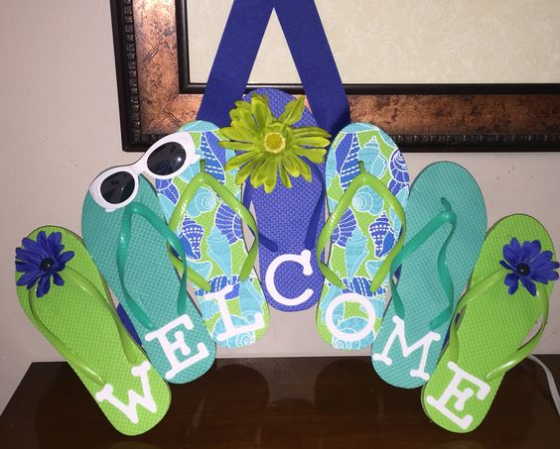

New Books

Danielle Steel- Against all odds

Patricia Cornwell- Ripper

James Patterson- Black Book

Jeffery Deaver- The Burial Hour

Sugar Creek Amish Mysteries Series, Books 1-20

ADM Last Day of School May 26th

1:00 dismissal



Getting ready for a family vacation? Before you spend countless hours flipping stations stop in and check out our new assortment of family Audio Books!

The Ugly Duckling

Sarah Plain and Tall

Lemony Snicket

Charlie and the Chocolate Factory

just to name a few!

Sizzling Storytime!

Join us monday afternoons at 3:00pm for some pint sized fun!

we will sings songs, and read books

geared toward ages 0-4

all ages are welcome

**Library** hours

Monday-12-5:30pm

Tuesday- 12-5:30pm

Wednesday- Closed

Thursday- 12-5:30pm

Friday- 12-6pm

Saturday-

9am-Noon

515-677-2712

Friday Funday's

Starting June 9th we will meet at Meek Park for Yoga at 9:30am following by Skating time from 10:00am-Noon!

We do beginner kids Yoga, I have printouts for everyone!

Thanks to Deb Fleishman's generous donations we have nice roller blades and skates for everyone to use!

There is no charge, come join the fun!

LEGO Club

June 15th

6:00-7:00

All ages welcome! Lego's and Duplo blocks will be provided. There will be a weekly theme. No Charge

Stay Tuned to this newsletter and our website...

**www.minburnlibrary.weebly.com**

so you don't miss out on the upcoming events here at

Minburn Public Library!

School's out! Skating Party!!

May 26th

2-4pm

Meek Park Skating Rink

popcorn & Lemonade Provided

Everyone welcome!

This publication is brought to you by Minburn Public Library

Currently a bi-monthly production



Reading

Rules

Library News