February, 20th 2017

**FREE**

**Minburn Moments**

Formerly the Pinhook Page

Chili Cheese Dog Bake

4 Hot Dogs 1 15oz. can of chili

##### 4 String Cheese (cheddar) 1 tsp. fresh parsley

##### 1Can Pillsbury pizza dough 1 tsp. garlic powder

##### 1/4 c butter, melted

##### Preheat oven to 375 degrees, remove cheese from wrappers and cut lengthwise. Open the can of pizza dough & roll out, cut into 4 pieces. Take a hotdog & sandwich it between the two pieces of cheese. Place in a pan with cheese side down. Pour chili in around the hot dogs. Bake 20-25 min, mix garlic and parsley with butter, brush onto the top. Enjoy!

Community

Calendar

February

15th- **Wednesday Club 5:45-7:15 Minburn Methodist Church**

16th- Lego Club

6-7pm @ Legion Hall

17th- Friday Funday

10am-Noon

Minburn Elementary

Gym

ADM No School

22nd- Wacky Wednesday 2-4pm

Paper Plate String Art

**Wednesday Club 5:45-7:15 Minburn Methodist Church**

23rd- Lego Club

6-7pm @ Legion Hall

24th- Friday Funday

10am-Noon

Minburn Elementary

Gym

March

1st- Craft Club- 7pm

at Legion Hall

**Wednesday Club 5:45-7:15 Minburn Methodist Church**

2nd- Library Board Meeting 6:30pm

3rd- Friday Funday

10am-Noon

Minburn Elementary

Gym

8th- **Wednesday Club 5:45-7:15 Minburn Methodist Church**

9th- Lego Club

6-7pm @ Legion Hall

10th- Friday Funday

10am-Noon

Minburn Elementary

Gym

Wednesday Club

Wednesdays

5:45pm-7:15pm

Ages 5 and up

meal provided

Minburn united

Methodist church

705 Chestnut street

Girl Scout cookies are here!  If you are interested in ordering, please contact Olivia at 515-677-2084 or abbycatgirl1@yahoo.com.  We will deliver!  Cookies in stock now!

Thank you!



**Annual 4-H Soup Supper**

Sunday, February 26th, 2017

Minburn Methodist Church

**4:30-6:00pm**

705 Chestnut St. Minburn, IA 50167

**Free Will Offering**

**Heartland Warriors 4H**

Call Karen 515-339-4477 for delivery

Minburn Public Library's Board of Trustee's is looking to fill a spot on the library board. If you are interested please contact the library at 515-677-2712 or library@ minburnlibrary.com

Saturday Morning

blood pressure checks are being postponed until further notice. Please stay tuned to see when they are being started again!

Area Churches

**United Methodist**

**Church**

Wednesday Club

Wednesday's

5:30-7:15pm

Church Service 11am

**Washington Chapel Church of Christ**

Sunday School 9:30am

Church 10:30am



# Have something to announce or advertise? How about something to sell? Put it on the Minburn Moments page!

# Contact Nicole at The Minburn Library call

# 515-677-2712 , email library@minburnlibrary.com or stop by I would be glad to add it in the next issue. Currently bi-monthly production.

City Hall Hours

Mon,Tue,Thur,Fri-

8am- Noon, 1-5pm

Wednesdays- Closed

Sat and Sun - Closed

515-677-2245

**Library** hours

Monday-12-5:30pm

Tuesday- 12-5:30pm

Wednesday- Closed

Thursday- 12-5:30pm

Friday- 12-6pm

Saturday- 9am-Noon

February Reader of the Month!

Chase Cline

Congratulations Chase! To be reader of the month stop in and check out books, the more you check out the more times your name goes into the bucket. I draw a name every month, you receive a goody bag and get your picture taken.

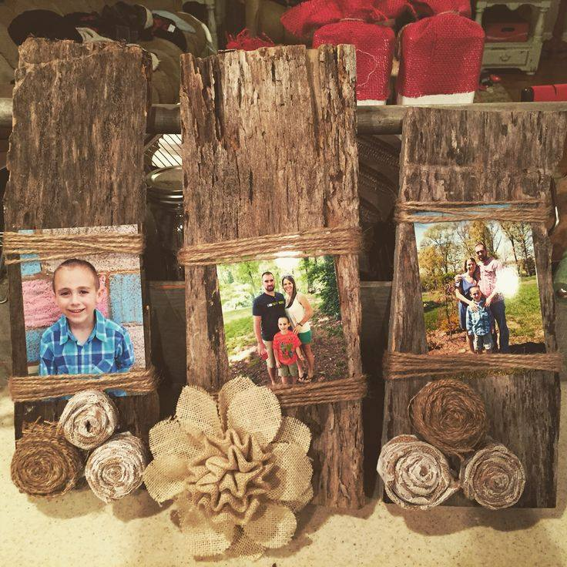

*Craft Club*

*March 1st, 2017*

*7:00pm*

*Minburn Legion Hall*

*Barn wood picture frame.*

*Free Will Donation*

*Please RSVP By February 25th.*

*515-677-2712*

*library@minburnlibrary.com*

*or our facebook page*

Sizzling Storytime!

COming in March!

Join us monday mornings at 10am for some pint sized fun!

we will sings songs, and read books

geared toward ages 0-4, but all ages are welcome

**Book Club**

**Discussion**

March 21st

**11:00am @ the Library**

**Room with a View**

**By: E.M. Forster**

**Everyone is welcome!**

**\*New* Evening Book Club**

**3rd Monday night of the month at 6:30pm. Beginning March 20th @ the Library**

A library is not a luxury but one of the necessities of life.

-Henry Ward Beecher

LEGO Club

February 23rd

6:00-7:00pm

All ages welcome! Lego's and Duplo blocks will be provided. There will be a weekly theme. No Charge

Once a month instead of weekly beginning in March.

Stay Tuned to this newsletter and our website...

**www.minburnlibrary.weebly.com**

so you don't miss out on the upcoming events here at Minburn Public Library!

Friday Funday's

Preschool Playtime has a new look!

Every Friday

10am-Noon

Minburn Elementary Gym

feel free to bring ride on toys, balls, and other smaller toys to play with.

ALL AGES WELCOME!!!

No Charge!

Reading

Rules



This publication is brought to you by Minburn Public Library

Currently a bi-monthly production

ADM -No school - February 17th



**Wacky Wednesday**

**February 22nd, 2017**

**Paper Plate String Art**

**2-4pm**

**Minburn Legion Hall**

**All Ages Welcome**

Library News!