February, 1st 2017

**FREE**

**Minburn Moments**

Formerly the Pinhook Page

Community

Calendar

February

1st- Wacky Wednesday 2-3pm

Critter Cindy -Dallas County Conservation @ Legion Hall

Craft Club 7:00pm

@ Legion Hall

**Wednesday Club 5:45-7:15 Minburn Methodist Church**

2nd- Lego Club 6-7pm

@ Legion Hall

Minburn Library Board Meeting 6:30pm @ Library

3rd- Friday Funday

10am-Noon

Minburn Elementary Gym

4th**- Annual Stag Supper 6:00pm @ Legion Hall**

8th- **Wednesday Club 5:45-7:15 Minburn Methodist Church**

10th- Friday Funday

10am-Noon

Minburn Elementary

Gym

15th- **Wednesday Club 5:45-7:15 Minburn Methodist Church**

17th- Friday Funday

10am-Noon

Minburn Elementary

Gym

ADM No School

22nd- Wacky Wednesday 2-4pm

Paper Plate String Art

**Wednesday Club 5:45-7:15 Minburn Methodist Church**

24th- Friday Funday

10am-Noon

Minburn Elementary

Gym

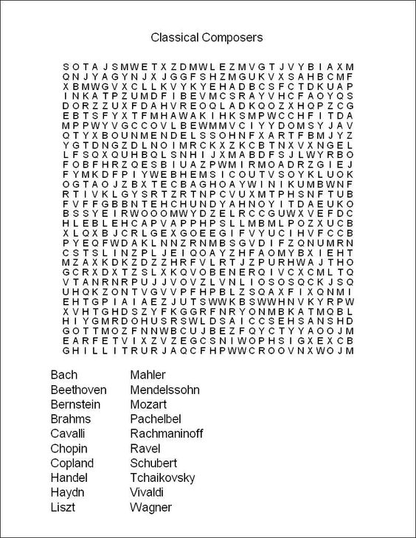

Girl Scout cookies are here!  If you are interested in ordering, please contact Olivia at 515-677-2084 or abbycatgirl1@yahoo.com.  We will deliver!  Cookies in stock on 2/7/2017.  Thank you!



Minburn

American Legion

Annual Stag Supper

February 4th, 2017

6:00pm $9.00 person

Raffle following supper Tickets are 1 For $2, 6 for $10, or 12 for $20

Grand Prize-Henry Big Boy

Free will bar

Area Churches

**United Methodist**

**Church**

Wednesday Club

Wednesday's

5:30-7:15pm

Church Service 11am

**Washington Chapel Church of Christ**

Sunday School 9:30am

Church 10:30am

Saturday Morning

blood pressure checks are being postponed until further notice. Please stay tuned to see when they are being started again!



# Have something to announce or advertise? How about something to sell? Put it on the Minburn Moments page!

# Contact Nicole at The Minburn Library call

# 515-677-2712 , email library@minburnlibrary.com or stop by I would be glad to add it in the next issue. Currently bi-monthly production.

City Hall Hours

Mon,Tue,Thur,Fri-

8am- Noon, 1-5pm

Wednesdays- Closed

Sat and Sun - Closed

515-677-2245

LEGO Club

February 9th

6:00-7:00pm

All ages welcome! Lego's and Duplo blocks will be provided. There will be a weekly theme. No Charge

**Every Thursday Night!**

Minburn Public Library's Board of Trustee's is looking to fill a spot on the library board. If you are interested please contact the library at 515-677-2712 or library@ minburnlibrary.com

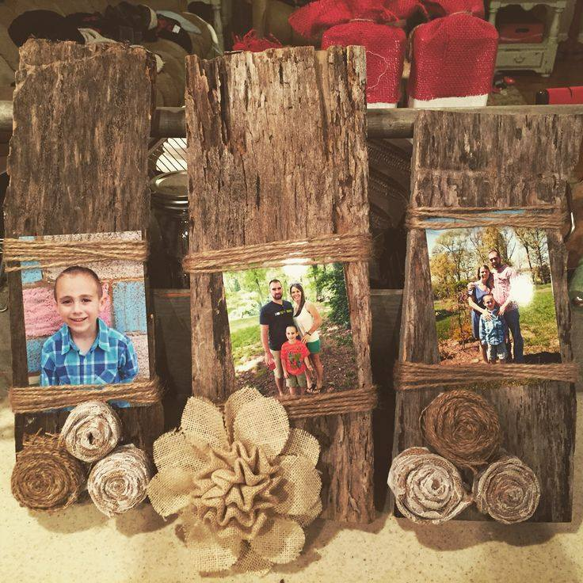

*Craft Club*

*March 1st, 2017*

*7:00pm*

*Minburn Legion Hall*

*Barn wood picture frame.*

*Limit 30 participants*

*Free Will Donation*

*If we reach 30 people I will host a second craft night March 8th 7-8pm*

*Please RSVP By February 25th.*

*515-677-2712*

*library@minburnlibrary.com*

*or our facebook page*

**Library** hours

Monday-12-5:30pm

Tuesday- 12-5:30pm

Wednesday- Closed

Thursday- 12-5:30pm

Friday- 12-6pm

Saturday- 9am-Noon

Friday Funday's

Preschool Playtime has a new look!

Every Friday

10am-Noon

Minburn Elementary Gym

feel free to bring, ride on toys, balls, and other smaller toys to play with.

FRIDAY February 17th

NO SCHOOL

ALL AGES WELCOME!!!

No Charge!

Stay Tuned to this newsletter and our website...

**www.minburnlibrary.weebly.com**

so you don't miss out on the upcoming events here at Minburn Public Library!

**Wacky Wednesday**

**February 22nd, 2017**

**Paper Plate String Art**

**2-4pm**

**Minburn Legion Hall**

**All Ages Welcome**

**Book Club**

**Discussion**

February 21st

**11:00am @ the Library**

**The Dollhouse**

**By: Fiona Davis**

**Everyone is welcome!**

ADM -No school - February 17th



This publication is brought to you by Minburn Public Library

Currently a bi-monthly production

Reading

Rules



Library News!