August 15th, 2017

**FREE**

*Minburn*

*Moments*

Formerly the Pinhook Page

Community

Calendar

August

15th- Open Skating

Meek Park 7-9pm

17th- Open Skating

Meek Park 7-9pm

18th- Friday Funday's

10-Noon Meek Park Skating Rink

23rd- First Day

of School!

2:30 dismiss

24th- 2:30 dismiss

30th- Wacky Wednesday

1:00 dismiss

FROZEN PARTY

Legion Hall

1:45-4pm

September

4th- LABOR DAY

Library/City Hall closed

6th- Craft Club- 7pm

Wednesday Club

Kick-Off 5:45-7:15pm

Minburn Methodist Church

13th- Wacky Wednesday- 1:00 dismiss

Library Event- 2-4pm

Minburn Legion

(details to come)

Wednesday Club-

5:45-7:15pm

14th- Lego Club 6-7pm

Legion Hall

20th- Wednesday Club

5:45-7:15pm

25th- Wednesday Club

5:45-7:15pm

Free Open Skating

Our last night will be Thursday August 17th

7-9pm

Meek Park Skating Rink

Skates Provided

Thank you to everyone who came and enjoyed the skating rink this year.

A huge Thank You to

Deb Fleishman for all her many skate donations, and helping to provide nice skates and roller blades for the youth to wear!

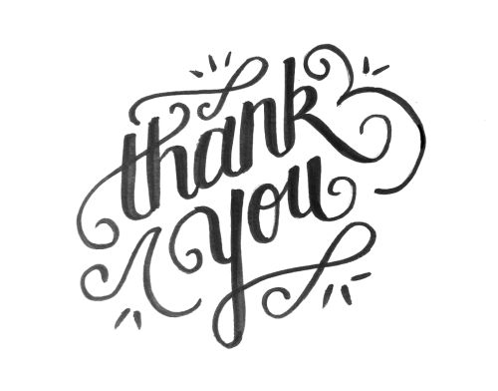

Wednesday Club is back in Action!

Kick- Off September 6th!

5:45-7:15pm

Minburn Methodist Church

meal provided

Sunday School starts Sept. 10th 10:00am

DONATIONS NEEDED!

The FRIENDS of the Minburn Library are collecting gently used items (no clothing) for our **“1st Annual Christmas Shop for Mom and Pop”** on Saturday, December 2nd (time tbd).

Kids are able to come ‘shop’ for a gift for mom and a gift for dad and have it wrapped….all for free! So parents have something special under the tree.

If you have items you would like to donate, please drop your items at the Library or contact Librarian, Nicole Connick at #677-2712 or Friend, Laura Bengtson at 677-2084. We will also pick up your items, if needed.

We would also love donations of gift wrap, tape, bows, and gift tags!

Donations being accepted now thru November 18th.

Left over items will be donated

Minburn City Hall & Minburn Public Library

will be closed

Monday, September 4th

for Labor Day

Annual Fall Minburn American Legion Fish Fry

October 20th, 2017

Details to follow, mark your calendars!

Saturday Morning

blood pressure checks are being postponed until further notice. Please stay tuned to see when they are being started again!

Area Churches

**United Methodist**

**Church**

Church Service 11am

**Washington Chapel Church of Christ**

Sunday School 9:30am

Church 10:30am



# Have something to announce or advertise? How about something to sell? Put it on the Minburn Moments page!

# Contact Nicole at The Minburn Library call

# 515-677-2712 , email library@minburnlibrary.com or stop by I would be glad to add it in the next issue. Currently bi-monthly production.

City Hall Hours

Mon,Tue,Thur,Fri-

8am- Noon, 1-5pm

Wednesdays- Closed

Sat and Sun - Closed

515-677-2245

**Book Club**

**Discussion**

Sept. 18th 6:30pm

Sept. 19th 11:00am

**The Witches Daughter**

**By: Paula Brackston**

Everyone is welcome!

books are available at the library to be checked out

**October-The Widow**

**By: Fiona Barton**

**New**Birthday Club**

Have a birthday

coming up?

Stop in the Library, have your picture taken with Beatrice our New Birthday Bear, and pick up your birthday

goody bag.

LEGO Club

September 14th

6:00-7:00

All ages welcome! Lego's and Duplo blocks will be provided.

No Charge

*Craft Club*

*September 6th, 2017*

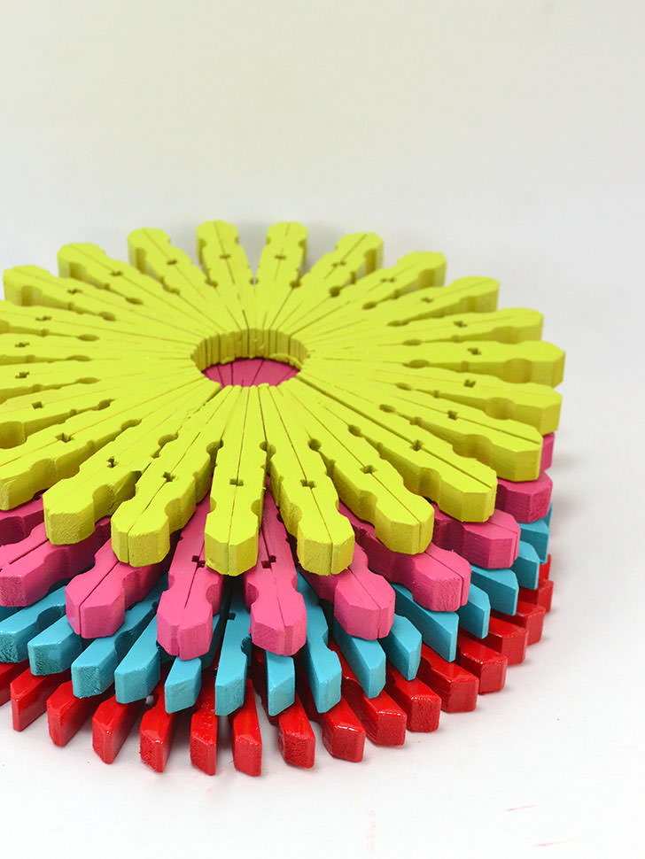

*Decorative Solar Lights*

*7:00pm*

*Minburn Legion Hall*

*Please bring E6000 glue if you have it availvable.*

*Snack will be provided*

*Bring your own Drinks*

*Free will donation*

Wacky Wednesday's Are Back!

FROZEN PARTY!

Wednesday

August 30th

1:45-4pm

Crafts, Snacks, Snow cones

and watch Frozen!

We are letting summer go and celebrating a new school year with our First Wacky Wednesday of the season.

Minburn American Legion

319 Baker St

Minburn

If questions please call

Nicole @ 677-2712

Stay Tuned to this newsletter and our website...

**www.minburnlibrary.weebly.com**

so you don't miss out on the upcoming events here at

Minburn Public Library!

Summer Reading Stats 2017!

I am so proud of all of our patrons! We had 27 people register

As a whole we read 304 books

Reading time was over 87hrs

There was 24 events throughout the summer

over 357 people attended those events!

13 kids completed the whole program!

**Grand Prize Winners**

**Benjimen Moen** won the Discover Iowa Book Set

**Payton Cummins** won the doll and clothes

**Aubree Timmer** won the Kindle Fire

Library hours

Monday-12-5:30pm

Tuesday- 12-5:30pm

Wednesday- Closed

Thursday- 12-5:30pm

Friday- 12-6pm

Saturday-

9am-Noon

515-677-2712

I would like to Thank...

Heartland Coop

For their donation to Build A Better World 2017! Summer Reading Program

Your help was much appreciated! Thank You!

Sizzling Storytime!

Join us Monday afternoons at 3:00pm for some pint sized fun!

we will sings songs, and read books

geared toward ages 0-4

all ages are welcome

Friday Funday's

Yoga at 9:30am

Open Skating time

10:00am-Noon!

Meek Park Skating Rink

We do beginner kids Yoga, I have printouts for everyone!

There is no charge, skates and roller blades are provided

come join the fun!

**We will remain at Meek Park until the weather changes. At that time we will move to the Minburn Elementary Gym**



Reading

Rules

This publication is brought to you by Minburn Public Library

Library News